**21.Pass or fail**

**Exercise**

* **Write a program to find out whether a student is pass or fail; if it requires a total of 40% and at least 33% in each subject to pass. Assume 3 subjects and take marks as input from the user**

**Approach:**

**So here we did like this**

**avg = (subject1 + subject2 + subject3)/3.0**

**If Conditions: avg>=40 && subject1>=33 && subject2>=33 && subject3>=33**

**print"Congratulations, You have been promoted"**

**Else print"Sorry, You have not been promoted! Please try again."**

**Solution 👇**

**Java :**

**import java.util.Scanner;**

**class CodeXam**

**{**

**public static void main(String [] args)**

**{**

**byte m1, m2, m3;**

**Scanner sc = new Scanner(System.in);**

**System.out.println("Enter your marks in Physics");**

**m1 = sc.nextByte();**

**System.out.println("Enter your marks in Chemistry");**

**m2= sc.nextByte();**

**System.out.println("Enter your marks in Mathematics");**

**m3 = sc.nextByte();**

**float avg = (m1+m2+m3)/3.0f; //you can do this also Marks Percentage = (What is the total number you got in the exam / The sum of the all subjects highest number ) X 100**

**System.out.println("Your Overall percentage is: " + avg);**

**if(avg>=40 && m1>=33 && m2>=33 && m3>=33){**

**System.out.println("Congratulations, You have been promoted");**

**}**

**else{**

**System.out.println("Sorry, You have not been promoted! Please try again.");**

**}**

**}**

**}**

**output:**

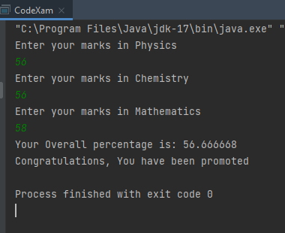

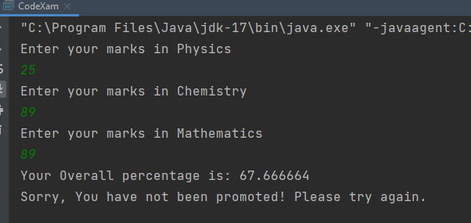

**Python :**

**physics = int(input("Enter your score in Physics:\n"))**

**chemistry = int(input("Enter your score in Chemistry:\n"))**

**mathematics = int(input("Enter your score in Mathematics:"))**

**result = (physics+chemistry+mathematics) / 3**

**print("\nYour overall percentage is", result)**

**if result >= 40 and physics >= 33 and chemistry >= 33 and mathematics >= 33:**

**print("Congratulations ! You've been promoted ")**

**else:**

**print("Ah , You've failed this year ! See you never :)")**

**output:**

